

**Savings features in Volopay**

Product Requirement Document | Aashish | May 2021

1. **Introduction**

Customers are using Volopay to skip the painful admin work and overcome the lack of visibility for making their payments for different subscriptions, employee reimbursements, vendor payouts, etc. It becomes essential for us to have a saving feature to help customers save time and money.

The goal of the savings feature is to :

* Track users' cashback on various spends done through cards.
* To create a better spending culture by introducing new features to reduce useless spending.
* Analyze corporate spending and identify the best possible way to save money that usually goes unnoticed.

1. **Success Criteria**

After adding this feature customers(Companies) will be able to save on their spending by receiving cashback and can further save by reducing duplicate spending. This will help us to convert X number of customers in 1 month [X is not a value right now as I don't have full information on all the parameters]

1. **Core Experience**

As a core experience for this project, we will build a feature that will provide the below insights to the user:

* Save money by reducing overspending
* Removing duplicate subscriptions
* Keeping track of all the employee’s spending.

1. **Understanding Users**

In order to get a better understanding of user needs, I interviewed potential customers and asked them about the problems they face while managing company finances. To get better insights, I chose to focus on users that have not used Volopay or any similar application(s) for finance management and must be probably using old-fashioned ways only.

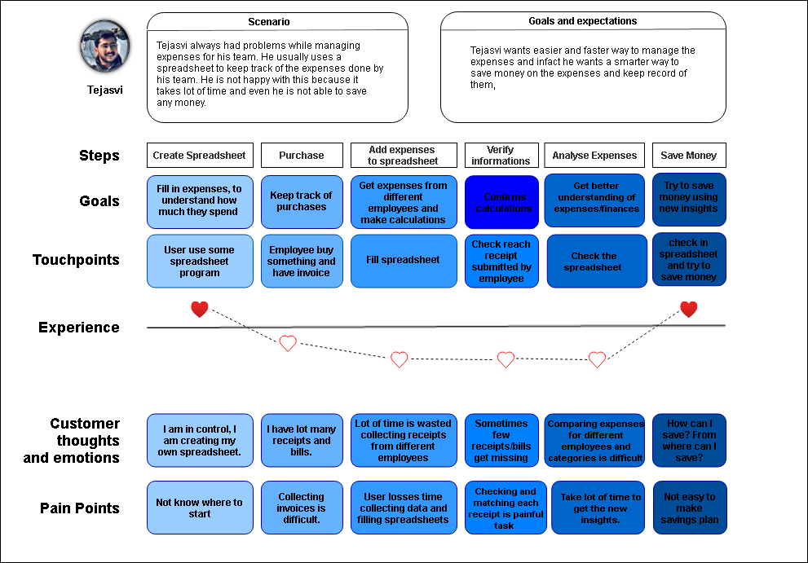

1. **Sketch**

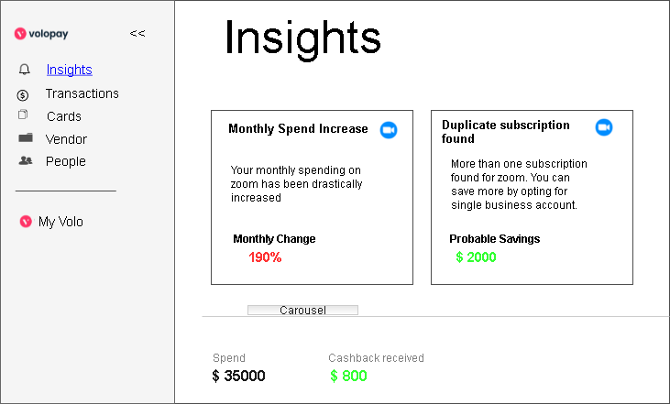

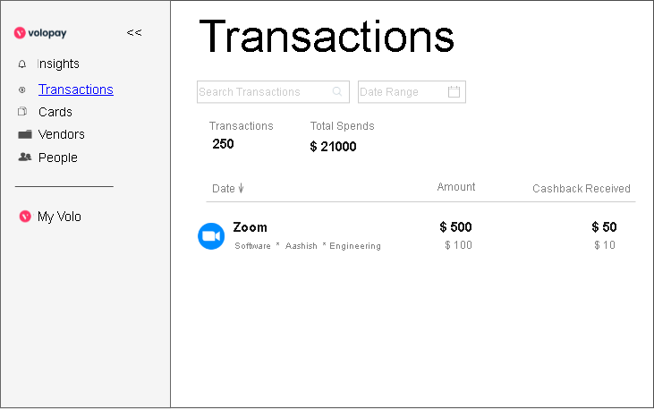

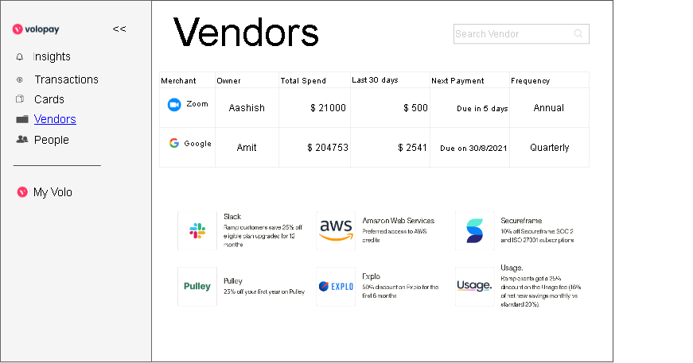

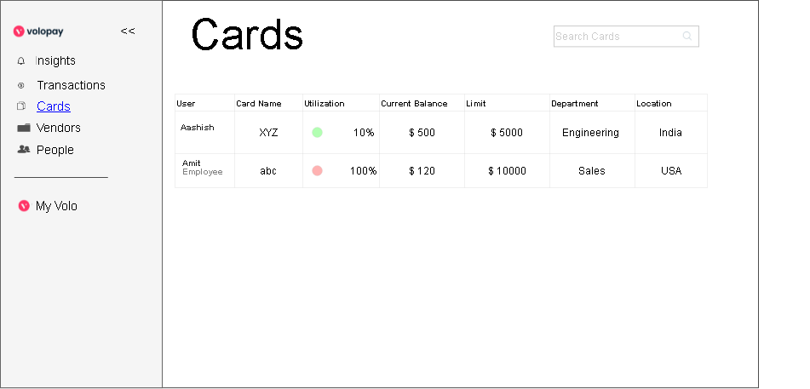

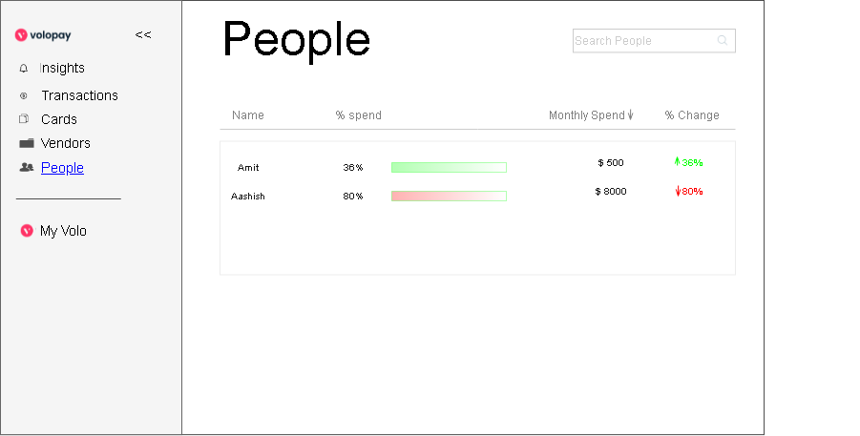

1. **Usability Test**

I introduced my concept to multiple individuals of various domains and designations working with different startups and organizations and I got to know about the perspective of people with different profiles and pain points regarding the assertions on usability and desirability of the feature. In order to have a clear process to follow and compare results, I asked the users to complete 3 different scenarios:

1. 1st Scenario(Insights Page):

**User Goal:** Use the Insight feature to get insights about spending.

**Task:** Use Volopay to help understand how you can save money by managing duplicate subscriptions, and monthly spending and get notifications about increased spending, various ongoing offers for different vendors, and total cashback earned.

1. 2nd Scenario(Transactions Page):

**User Goal:** Use the Transactions feature to see how much you can save on every spend.

**Task:** Use Volopay to get all your transactions in one place for different vendors and subscriptions and see how much you have saved on each transaction by receiving cashbacks**.**

1. 3rd Scenario(Vendors Page):

**User Goal:** Use the Vendors feature to see how much you can save with ongoing offers provided by vendors.

**Task:** Use Volopay to get all your vendors in one place and also you can search them category-wise. Here you can see the status of all the vendors who are providing subscriptions to our employees and get regular offers provided by vendors on their subscriptions.



**Savings feature to drive marketing growth strategy**

Product Requirement Document | Aashish | May 2021

1. **Problem**

* Customers need to calculate manually to get a rough idea about their savings.
* How might we enable customers to know how much they can save using Volopay?

1. **Assumptions/Hypothesis**

* Customers might want to get a rough estimate of how much they can save.

1. **Goal**

* To add a feature on a website that can provide customers a rough estimate of how much they can save using Volopay. To acquire more customers by 20%.

1. **User Stories**

* As a user, I want to manage my finances more precisely, so that it will save my time and money.
* As a user, I want to inspect duplicate spends, so that I will be able to save money.
* As a user, I want a platform to show me curated offers, so that I don’t have to waste my time looking for offers on other platforms.

1. **Designs**

The below designs will help:

* To calculate monthly and yearly savings by entering your monthly/yearly spendings.
* To display the best curated offers for customers offered by vendors.

Follow the below steps to calculate the monthly/yearly expenses:

1. Select monthly/yearly from the drop-down menu.
2. Enter monthly/yearly spending using slider
3. On the right side, you will get savings:
   1. Amount you will receive as 2% cashback.
   2. Approx. amount volopay can help you save.
   3. Total monthly/yearly savings (2%cash back + Volopay savings)



